# **Automated pollen grains-Prediction**

**Automated Pollen Grains Prediction** is the process of using artificial intelligence (AI), especially image processing and machine learning, to identify and classify pollen grains from microscopic images without manual effort.

* **Steps:**
  + **Image Capture:** Microscopic images of pollen are collected.
  + **Preprocessing:** Images are cleaned and enhanced for clarity.
  + **Segmentation:** Pollen grains are separated from the background.
  + **Feature Extraction:** Shape, texture, and size features are measured.
  + **Classification:** ML/DL models (like CNNs) predict the pollen type.
* **Benefits:** Fast, accurate, and reduces manual labor in allergy forecasting, agriculture, and climate research.

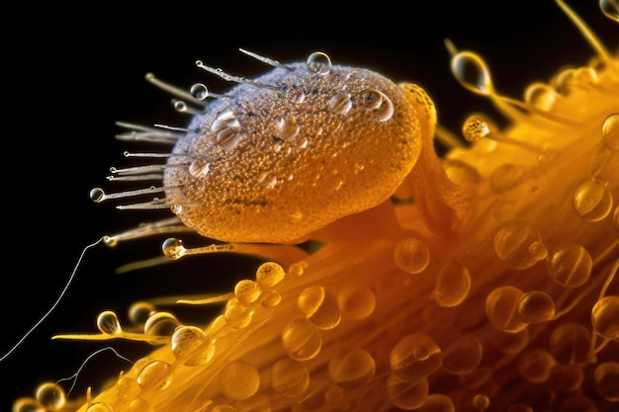

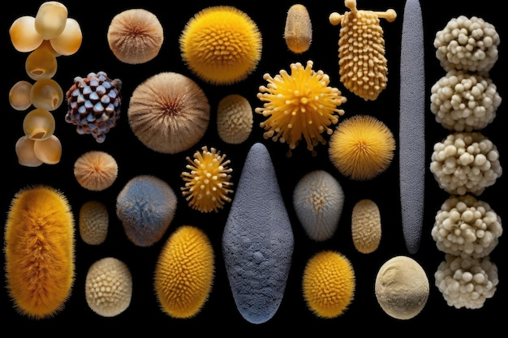



**Objective :**

The main objective of automated pollen grains prediction is to accurately and efficiently identify, classify, and quantify pollen grains in environmental or biological samples using automated techniques such as image processing and machine learning. This helps to:

* Reduce manual effort and human error in pollen analysis
* Enable real-time monitoring of pollen levels
* Improve allergy forecasting and public health responses
* Support research in botany, agriculture, and climate science

### **Context :**

Pollen analysis, or palynology, is traditionally performed manually by trained experts using microscopes to identify and count pollen grains. This process is **time-consuming, labor-intensive, and prone to human error**. With rising concerns over **allergic diseases**, **climate change**, and **air quality**, there is a growing need for **fast, accurate, and scalable** pollen detection methods.

Advancements in **digital imaging**, **machine learning**, and **deep learning** have enabled the development of **automated systems** that can process microscopic images and accurately classify pollen grains. These systems are being increasingly adopted in **environmental monitoring stations**, **medical research**, and **agricultural studies** to support data-driven decision-making and enhance predictive accuracy.

**Content:**

| **Feature** | **Description** |
| --- | --- |
| Image Acquisition | Captures high-resolution microscopic images of pollen grains from environmental samples using digital microscopes or scanners. |
| Preprocessing | Enhances image quality by removing noise, adjusting contrast, and normalizing the images to ensure consistent analysis. |
| Segmentation | Detects and isolates individual pollen grains from the background using techniques such as thresholding or deep learning segmentation (e.g., U-Net). |
| Feature Extraction | Identifies key visual features like shape, size, texture, and color which are critical for distinguishing different pollen types. |
| Classification | Uses machine learning (SVM, Random Forest) or deep learning (CNN, ResNet) models to classify pollen into different species or families. |
| Quantification | Counts the number of each pollen type in a sample, useful for allergen level predictions and statistical analysis. |
| Data Storage & Reporting | Stores classified results in a database and generates reports for analysis, sharing, or integration with other systems (e.g., health apps). |
| Real-time Processing | Enables real-time or near-real-time prediction and monitoring, especially useful in allergy forecasting and environmental alerts. |
| User Interface (UI) | Provides an easy-to-use dashboard or software interface for viewing predictions, uploading images, and managing data. |